Learn Visual Basic 6

1. Introduction to the Visual Basic Environment

Preview

- In this first class, we will do a quick overview of how to build an application in Visual Basic. You’ll learn a new vocabulary, a new approach to programming, and ways to move around in the Visual Basic environment. You will leave having written your first Visual Basic program.

Course Objectives

- Understand the benefits of using Microsoft Visual Basic 6 as an application tool
- Understand the Visual Basic event-driven programming concepts, terminology, and available tools
- Learn the fundamentals of designing, implementing, and distributing a Visual Basic application
- Learn to use the Visual Basic toolbox
- Learn to modify object properties
- Learn object methods
- Use the menu design window
- Understand proper debugging and error-handling procedures
- Gain a basic understanding of database access and management using databound controls
- Obtain an introduction to ActiveX controls and the Windows Application Programming Interface (API)

What is Visual Basic?

- Visual Basic is a tool that allows you to develop Windows (Graphic User Interface - GUI) applications. The applications have a familiar appearance to the user. As you develop as a Visual Basic programmer, you will begin to look at Windows applications in a different light. You will recognize and understand how various elements of Word, Excel, Access and other applications work. You will develop a new vocabulary to describe the elements of Windows applications.

- Visual Basic is event-driven, meaning code remains idle until called upon to respond to some event (button pressing, menu selection, ...). Visual Basic is governed by an event processor. Nothing happens until an event is detected. Once an event is detected, the code corresponding to that event (event procedure) is executed. Program control is then returned to the event processor.

Event?
Event processor

Event
Basic
Code
Basic
Code
Basic
Code
Procedures

All Windows applications are event-driven. For example, nothing happens in Word until you click on a button, select a menu option, or type some text. Each of these actions is an event.

- The event-driven nature of Visual Basic makes it very easy to work with. As you develop a Visual Basic application, event procedures can be built and tested individually, saving development time. And, often event procedures are similar in their coding, allowing re-use (and lots of copy and paste).

- Some Features of Visual Basic

- Full set of controls - you 'draw' the application
- Lots of icons and pictures for your use
- Response to mouse and keyboard actions
- Clipboard and printer access
- Full array of mathematical, string handling, and graphics functions
- Can handle fixed and dynamic variable and control arrays
- Sequential and random access file support
- Useful debugger and error-handling facilities
- Powerful database access tools
- ActiveX support
- Package & Deployment Wizard makes distributing your applications simple

Visual Basic 6 versus Other Versions of Visual Basic

- The original Visual Basic for DOS and Visual Basic For Windows were introduced in 1991.

- Visual Basic 3 (a vast improvement over previous versions) was released in 1993.

- Visual Basic 4 released in late 1995 (added 32 bit application support).

- Visual Basic 5 released in late 1996. New environment, supported creation of ActiveX controls, deleted 16 bit application support.

- And, now Visual Basic 6 - some identified new features of Visual Basic 6:

- Faster compiler
- New ActiveX data control object
- Allows database integration with wide variety of applications
- New data report designer
- New Package & Deployment Wizard
- Additional internet capabilites

- Applications built using Visual Basic 6 will run with Windows 95, Windows 98, Windows 2000, or Windows NT.

Structure of a Visual Basic Application

Project (.VBP, .MAK)
Form 2 (.FRM)
Form 3 (.FRM)
Module 1 (.BAS)
Form 1 (.FRM)

Control 1
Control 1
Control 1

Control 2
Control 2
Control 2
Control 3
Control 3
Control 3

Application (Project) is made up of:

- Forms - Windows that you create for user interface
- Controls - Graphical features drawn on forms to allow user interaction (text boxes, labels, scroll bars, command buttons, etc.) (Forms and Controls are objects.)
- Properties - Every characteristic of a form or control is specified by a property. Example properties include names, captions, size, color, position, and contents. Visual Basic applies default properties. You can change properties at design time or run time.
- Methods - Built-in procedure that can be invoked to impart some action to a particular object.
- Event Procedures - Code related to some object. This is the code that is executed when a certain event occurs.
- General Procedures - Code not related to objects. This code must be invoked by the application.
- Modules - Collection of general procedures, variable declarations, and constant definitions used by application.

Steps in Developing Application

- The Visual Basic development environment makes building an application a straightforward process. There are three primary steps involved in building a Visual Basic application:

- Draw the user interface by placing controls on the form
- Assign properties to controls
- Attach code to control events (and perhaps write other procedures)

These same steps are followed whether you are building a very simple application or one involving many controls and many lines of code.

- The event-driven nature of Visual Basic allows you to build your application in stages and test it at each stage. You can build one procedure, or part of a procedure, at a time and try it until it works as desired. This minimizes errors and gives you, the programmer, confidence as your application takes shape.

- As you progress in your programming skills, always remember to take this sequential approach to building a Visual Basic application. Build a little, test a little, modify a little and test again. You’ll quickly have a completed application. This ability to quickly build something and try it makes working with Visual Basic fun – not a quality found in some programming environments! Now, we’ll start Visual Basic and look at each step in the application development process.

Starting Visual Basic

- We assume you have Visual Basic 6 installed and operational on your computer. If you don’t, you need to do this first. To start Visual Basic:

- Click on the Start button on the Windows task bar.
- Select Programs, then Microsoft Visual Basic 6
- Click on Visual Basic 6

(Some of the headings given here may differ slightly on your computer, but you should have no trouble finding the correct ones.)

- Visual Basic will start and this dialog box appears:

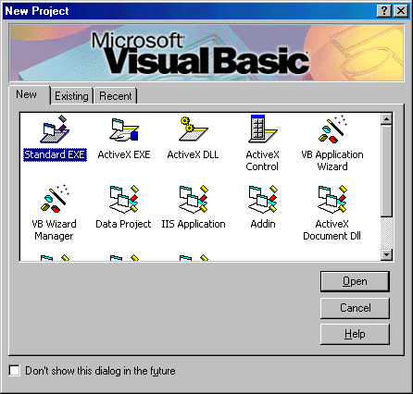

For now, just click Open – we are starting a new project. Later, once you have saved some projects, they can be opened using the Existing and Recent tabs. The Visual Basic development environment will start.

Drawing the User Interface and Setting Properties

• Visual Basic operates in three modes.

- Design mode - used to build application
- Run mode - used to run the application
- Break mode - application halted and debugger is available

We focus here on the design mode.

• Six windows appear when you start Visual Basic. Each window can be viewed (made visible) by selecting menu options, depressing function keys or using the toolbar. Use the method you feel most comfortable with.

- The Main Window consists of the title bar, menu bar, and toolbar. The title bar indicates the project name, the current Visual Basic operating mode, and the current form. The menu bar has drop-down menus from which you control the operation of the Visual Basic environment. The toolbar has buttons that provide shortcuts to some of the menu options. The main window also shows the location of the current form relative to the upper left corner of the screen (measured in twips) and the width and length of the current form. Of particular interest is the Help menu item. The Visual Basic on-line help system is invaluable as you build applications. Become accustomed with its use. Usually just pressing <F1> can get you the help you need.

Code Editor Tasks
Form position
Run
Object Browser
Stop
Form dimensions
Menu editor
Form Layout
Pause
Project
Explorer
Toolbox
Save project
Properties window
New form
Open project
Add project

- The Form Window is central to developing Visual Basic applications. It is where you draw your application.

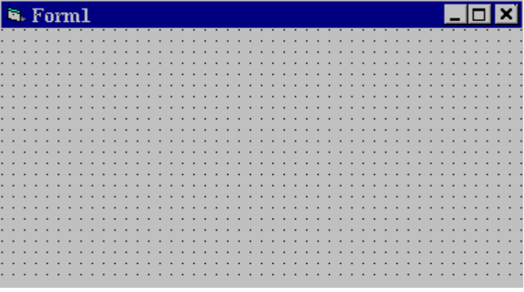

- The Toolbox is the selection menu for controls used in your application. Help with any control is available by clicking the control and pressing <F1>.

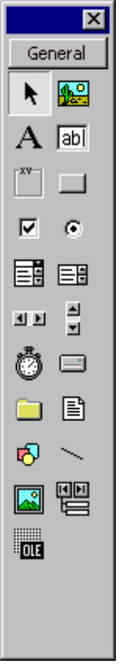
Pointer
Label
Frame
Check Box
Combo Box
Horizontal Scroll Bar
Timer
Directory List Box
Shapes
Image Box
Object Linking Embedding
Picture Box
Text Box
Command Button
Option Button
List Box
Vertical Scroll Bar
Drive List Box
File List Box
Lines
Data Tool
- The Properties Window is used to establish initial property values for objects (controls). The drop-down box at the top of the window lists all objects in the current form. Two views are available: Alphabetic and Categorized. Under this box are the available properties for the currently selected object. Help with any property can be obtained by highlighting the property of interest and pressing <F1>.

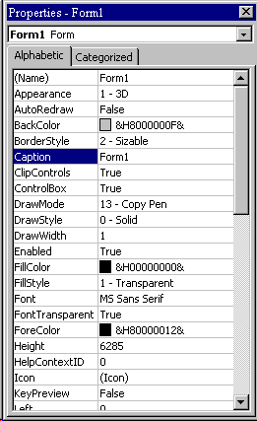

- The Form Layout Window shows where (upon program execution) your form will be displayed relative to your monitor’s screen:

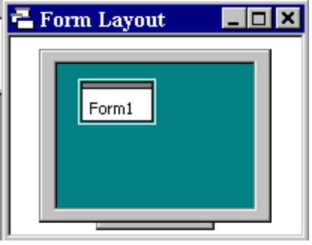

- The Project Window displays a list of all forms and modules making up your application. You can also obtain a view of the Form or Code windows (window containing the actual Basic coding) from the Project window.

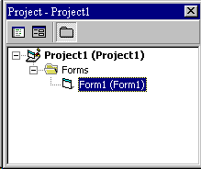

- As mentioned, the user interface is ‘drawn’ in the form window. There are two ways to place controls on a form:

- Double-click the tool in the toolbox and it is created with a default size on the form. You can then move it or resize it.

- Click the tool in the toolbox, then move the mouse pointer to the form window. The cursor changes to a crosshair. Place the crosshair at the upper left corner of where you want the control to be, press the left mouse button and hold it down while dragging the cursor toward the lower right corner. When you release the mouse button, the control is drawn.

- To move a control you have drawn, click the object in the form window and drag it to the new location. Release the mouse button.

- To resize a control, click the object so that it is select and sizing handles appear. Use these handles to resize the object.

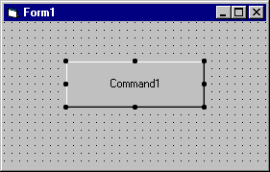
Click here to move object
Use sizing handles to resize object
Example 1-1

Stopwatch Application - Drawing Controls

1. Start a new project. The idea of this project is to start a timer, then stop the timer and compute the elapsed time (in seconds).

2. Place three command buttons and six labels on the form. Move and size the controls and form so it looks something like this:

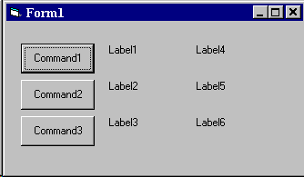

- Save this project (saved as Example1-1 in LearnVB6\VB Code\Class 1 folder).

Setting Properties of Objects at Design Time

• Each form and control has properties assigned to it by default when you start up a new project. There are two ways to display the properties of an object. The first way is to click on the object (form or control) in the form window. Then, click on the Properties Window or the Properties Window button in the tool bar. The second way is to first click on the Properties Window. Then, select the object from the Object box in the Properties Window. Shown is the Properties Window for the stopwatch application:

The drop-down box at the top of the Properties Window is the Object box. It displays the name of each object in the application as well as its type. This display shows the Form object. The Properties list is directly below this box. In this list, you can scroll through the list of properties for the selected object. You may select a property by clicking on it. Properties can be changed by typing a new value or choosing from a list of predefined settings (available as a drop down list). Properties can be viewed in two ways: Alphabetic and Categorized.

A very important property for each object is its name. The name is used by Visual Basic to refer to a particular object in code.

• A convention has been established for naming Visual Basic objects. This convention is to use a three letter prefix (depending on the object) followed by a name you assign. A few of the prefixes are (we’ll see more as we progress in the class):

Object Prefix Example
Form frm frmWatch
Command Button cmd, btn cmdExit, btnStart
Label lbl lblStart, lblEnd
Text Box txt txtTime, txtName
Menu mnu mnuExit, mnuSave
Check box chk chkChoice
• Object (control) names can be up to 40 characters long, must start with a letter, must contain only letters, numbers, and the underscore (_) character. Names are used in setting properties at run time and also in establishing procedure names for object events. Use meaningful object names that help you (or another programmer) understand the purpose of the respective controls.

Setting Properties at Run Time

• You can also set or modify properties while your application is running. To do this, you must write some code. The code format is:

ObjectName.Property = NewValue

Such a format is referred to as dot notation. For example, to change the BackColor property of a form name frmStart, we'd type:

frmStart.BackColor = vbBlue

How Names are Used in Control Events

• The names you assign to controls are used by Visual Basic to set up a framework of event-driven procedures for you to add code to. The format for each of these subroutines (all event procedures in Visual Basic are subroutines) is:

Private Sub ObjectName_Event (Optional Arguments)
.
.
End Sub

• Visual Basic provides the Sub line with its arguments (if any) and the End Sub statement. You provide any needed code.

Example 1-2

Stopwatch Application - Setting Properties

1. Set properties of the form, three buttons, and six labels:

Form1:
BorderStyle 1-Fixed Single
Caption Stopwatch Application
Name frmStopWatch

Command1:
Caption &Start Timing
Name cmdStart

Command2:
Caption &End Timing
Name cmdEnd

Command3:
Caption E&xit
Name cmdExit

Label1:
Caption Start Time

Label2:
Caption End Time

Label3:
Caption Elapsed Time

Label4:
BorderStyle 1-Fixed Single
Caption [Blank]
Name lblStart

Label5:
BorderStyle 1-Fixed Single
Caption [Blank]
Name lblEnd

Label6:
BorderStyle 1-Fixed Single
Caption [Blank]
Name lblElapsed

In the Caption properties of the three command buttons, notice the ampersand (&). The ampersand precedes a button's access key. That is, in addition to clicking on a button to invoke its event, you can also press its access key (no need for a mouse). The access key is pressed in conjunction with the Alt key. Hence, to invoke 'Start Timing', you can either click the button or press Alt+S. Note in the button captions on the form, the access keys appear with an underscore (_).

2. Your form should now look something like this:

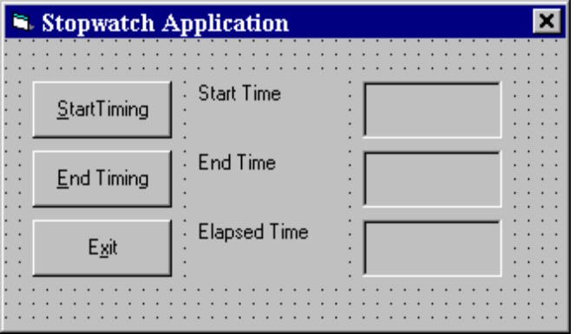

- Save this project (saved as Example1-2 in LearnVB6\VB Code\Class 1 folder).

Writing Code

- The last step in building a Visual Basic application is to write code using the BASIC language. This is the most time consuming task in any Visual Basic application. As controls are added to a form, Visual Basic automatically builds a framework of all event procedures. We simply add code to the event procedures we want our application to respond to. And, if needed, we write general procedures. For those who may have never programmed before, the code in these procedures is simply a line by line list of instructions for the computer to follow.

- Code is placed in the code window. Learn how to access the code window using the menu (View), toolbar, or by pressing <F7> (and there are still other ways). At the top of the code window are two boxes, the object (or control) list and the procedure list. Select an object and the corresponding event procedure. A blank procedure will appear in the window where you write BASIC code.

Variables

- We’re now ready to attach code to our application. As controls are added to the form, Visual Basic automatically builds a framework of all event procedures. We simply add code to the event procedures we want our application to respond to. But before we do this, we need to discuss variables.

- Variables are used by Visual Basic to hold information needed by your application. Rules used in naming variables:

- No more than 40 characters
- They may include letters, numbers, and underscore (_)
- The first character must be a letter
- You cannot use a reserved word (word needed by Visual Basic)

Use meaningful variable names that help you (or other programmers) understand the purpose of the information stored by the variable.

Visual Basic Data Types

Data Type Suffix Example
Boolean None True
Integer % 14
Long (Integer) & 4532838
Single (Floating) ! 3.23
Double (Floating) # 3.2346363627281
Currency @ $12.98
Date None 12/30/99
Object None n/a
String $ “Visual Basic 6”
Variant None any

Variable Declaration

• There are three ways for a variable to be typed (declared):

- Default
- Implicit
- Explicit

• If variables are not implicitly or explicitly typed, they are assigned the variant type by default. The variant data type is a special type used by Visual Basic that can contain numeric, string, or date data.

• To implicitly type a variable, use the corresponding suffix shown above in the data type table. For example,

TextValue$ = "This is a string"

creates a string variable, while

Amount% = 300

creates an integer variable. Implicit variable typing is recognized by Visual Basic to insure compatibility with older versions of the BASIC language.

• There are many advantages to explicitly typing variables. Primarily, we insure all computations are properly done, mistyped variable names are easily spotted, and Visual Basic will take care of insuring consistency in upper and lower case letters used in variable names. Because of these advantages, and because it is good programming practice, we will explicitly type all variables.

• To explicitly type a variable, you must first determine its scope. There are four levels of scope:

- Procedure level
- Procedure level, static
- Form and module level
- Global level

- The value of procedure level variables are only available within a procedure. Such variables are declared within a procedure using the Dim statement:

Dim MyInt as Integer

Dim MyDouble as Double
Dim MyString As String, YourString as String

Procedure level variables declared in this manner do not retain their value once a procedure terminates.

• To make a procedure level variable retain its value upon exiting the procedure, replace the Dim keyword with Static:

Static MyInt as Integer
Static MyDouble as Double

• Form (module) level variables retain their value and are available to all procedures within that form (module). Form (module) level variables are declared in the declarations part of the general object in the form's (module's) code window. The Dim keyword is used:

Dim MyInt as Integer
Dim MyDate as Date

• Global level variables retain their value and are available to all procedures within an application. Module level variables are declared in the declarations part of the general object of a module's code window. (It is advisable to keep all global variables in one module.) Use the Global keyword:

Global MyInt as Integer
Global MyDate as Date

- What happens if you declare a variable with the same name in two or more places? More local variables shadow (are accessed in preference to) less local variables. For example, if a variable MyInt is defined as Global in a module and declared local in a routine MyRoutine, while in MyRoutine, the local value of MyInt is accessed. Outside MyRoutine, the global value of MyInt is accessed.

- Example of Variable Scope:

Module1
Global X as Integer

Form1 Form2
Dim Y as Integer Dim Z as Single

Sub Routine1() Sub Routine3()
Dim A as Double Dim C as String
. .
. .
End Sub End Sub

Sub Routine2()
Static B as Double
.
.
End Sub

Procedure Routine1 has access to X, Y, and A (loses value upon termination)
Procedure Routine2 has access to X, Y, and B (retains value)
Procedure Routine3 has access to X, Z, and C (loses value)

Example 1-3

Stopwatch Application - Attaching Code

All that’s left to do is attach code to the application. We write code for every event a response is needed for. In this application, there are three such events: clicking on each of the command buttons. Don’ t worry if you don’t recognize or understand the code in this example – you don’t need to at this point. Just type the code as given. As you progress in the course, you will become very proficient at writing and understanding code.

- Double-click anywhere on the form to open the code window. Or, select ‘View Code’ from the project window.

- Click the down arrow in the Object box and select the object named (general). The Procedure box will show (declarations). Here, you declare three form level variables:

Option Explicit

Dim StartTime As Variant
Dim EndTime As Variant
Dim ElapsedTime As Variant

The Option Explicit statement forces us to declare all variables. The other lines establish StartTime, EndTime, and ElapsedTime as variables global within the form.

- Select the cmdStart object in the Object box. If the procedure that appears is not the Click procedure, choose Click from the procedure box. Type the following code which begins the timing procedure. Note the Sub and End Sub statements are provided for you:

Private Sub cmdStart_Click ()
‘Establish and print starting time
StartTime = Now
lblStart.Caption = Format(StartTime, "hh:mm:ss")
lblEnd.Caption = ""
lblElapsed.Caption = ""
End Sub

You should be able to see what happens here. In this procedure, once the Start Timing button is clicked, we read the current time (Now) and display it in a label box (the Format function converts the time to a standard hours, minutes, seconds form). We also blank out the other label boxes. In the code above (and in all code in these notes), any line beginning with a single quote (‘) is a comment. You decide whether you want to type these lines or not. They are not needed for proper application operation.

- Now, code the cmdEnd button.

Private Sub cmdEnd_Click ()
‘Find the ending time, compute the elapsed time
‘Put both values in label boxes
EndTime = Now
ElapsedTime = EndTime - StartTime
lblEnd.Caption = Format(EndTime, "hh:mm:ss")
lblElapsed.Caption = Format(ElapsedTime, "hh:mm:ss")
End Sub

Here, when the End Timing button is clicked, we read the current time (End Time), compute the elapsed time, and put both values in their corresponding label boxes.

- And, finally the cmdExit button.

Private Sub cmdExit_Click ()
End
End Sub

This routine simply ends the application once the Exit button is clicked.

- Did you notice that as you typed in the code, Visual Basic does automatic syntax checking on what you type (if you made any mistakes, that is)?

- Run your application by clicking the Run button on the toolbar, or by pressing <f5>. Pretty easy, wasn’t it?

- Save your application - see the Primer on the next page. Use the Save Project As option under the File menu. Make sure you save both the form and the project files. This is saved as Example1-3 in LearnVB6\VB Code\Class 1 folder.

- If you have the time, some other things you may try with the Stopwatch Application:

- Try changing the form color and the fonts used in the label boxes and command buttons.

- Notice you can press the ‘End Timing’ button before the ‘Start Timing’ button. This shouldn’t be so. Change the application so you can’t do this. And make it such that you can’t press the ‘Start Timing’ until ‘End Timing’ has been pressed. Hint: Look at the command button Enabled property.

- Can you think of how you can continuously display the ‘End Time’ and ‘Elapsed Time’? This is a little tricky because of the event-driven nature of Visual Basic. Look at the Timer tool. See the exercise at the end of the class for help on this one.

Quick Primer on Saving Visual Basic Applications:

When saving Visual Basic applications, you need to be concerned with saving both the forms (.FRM) and modules (.BAS) and the project file (.VBP). In either case, make sure you are saving in the desired directory. The current directory is always displayed in the Save window. Use standard Windows techniques to change the current directory.

The easiest way to save a new project is to click the Save Project button (it looks like a floppy disk) on the Visual Basic toolbar. First, you will be asked where you want to save your forms and modules, then where you want to save your project file. Once you’ve done this, subsequent clicking on the Save Project toolbar button will automatically save your forms, modules, and project file in their specified locations. To open a saved project, simply click the Open Project button (looks like a file folder).

If your prefer to save without the toolbar, there are four Save commands available under the File menu in Visual Basic:

Save [Form Name] Save the currently selected form or module with the current name. The selected file is identified in the Project window.
Save [Form Name] As Like Save File, however you have the option to change the file name
Save Project Saves all forms and modules in the current project using their current names and also saves the project file.
Save Project As Like Save Project, however you have the option to change file names. When you choose this option, if you have not saved your forms or modules, you will also be prompted to save those files. I always use this for new projects.

There is a corresponding Open command under the File menu to open project files.
Class Review

- After completing this class, you should understand:

  - The concept of an event-driven application
  - The parts of a Visual Basic application (form, control, property, event, …)
  - The various windows of the Visual Basic environment
  - How to use the Visual Basic on-line help system
  - The three steps in building a Visual Basic application
  - Two ways to place controls on a form
  - Methods to set properties for controls
  - Proper control naming convention
  - Proper variable naming and typing procedures
  - The concept of variable scope
  - How to add code in the code window
  - How to save a Visual Basic project

Practice Problems 1*

Problem 1-1. Beep Problem. Build an application with a command button. When the button is clicked, make the computer beep (use the Beep function).

Problem 1-2. Caption Problem. Build an application with a command button. When the button is clicked, change the button’s Caption property. This allows a command button to be used for multiple purposes. If you want to change the button caption back when you click again, you’ll need an If statement. We’ll discuss this statement in the next class, but, if you’re adventurous, look in on-line help to try it.

Problem 1-3. Enabled Problem. Build an application with two command buttons. When you click one button, make it disabled (Enabled = False) and make the other button enabled (Enabled = True).

Problem 1-4. Date Problem. Build an application with a command button. When the button is clicked, have the computer display the current date in a label control.

*Note: Practice Problems are given after each class to give you practice in writing code for your Visual Basic applications. These are meant to be quick and, hopefully, short exercises. The Visual Basic environment makes it easy to build and test quick applications – in fact, programmers develop such examples all the time to test some idea they might have. Use your imagination in working the problems – modify them in any way you want. You learn programming by doing programming! The more you program, the better programmer you will become. Our solutions to the Practice Problems are provided as a separate chapter to these notes.

Exercise 1*

Calendar/Time Display

Design a window that displays the current month, day, and year. Also, display the current time, updating it every second (look into the Timer control). Make the window look something like a calendar page. Play with object properties to make it pretty.

*Note: After completing each class’ notes, a homework exercise (and, sometimes, two) is given, covering many of the topics taught. Try to work through the homework exercise on your own. This is how programming is learned – solving a particular problem. For reference, solutions to all Exercises are provided as a separate chapter to these notes. In our solutions, you may occasionally see something you don’t recognize. When this happens, use the on-line help system to learn what’s going on. This is another helpful skill – understanding other people’s applications and code.

This page intentionally not left blank.

